Конкурс
“My Summer Adventure”

Автор: ученица 5 класса Мельникова Анна
Учитель: Тихомирова Анна Викторовна
МБОУ г. Владимира
«СОШ № 2 имени Героя Советского Союза
Жукова И.Е.»
г. Владимир
Владимирская область

2012 год

My summer adventures in Paris.
In June I with my father and our Russian team went to France. We took part in European Cup JKA Karate in Paris. Twenty three countries of Europe took part in these competitions. The competitions were very interesting and friendly. I met a lot of great sportsmen and we spoke about karate. Our Russian team got the first place in European Cup JKA Karate, I got the third place in Individual Kata. I was very proud of our Russian team and our great Motherland.

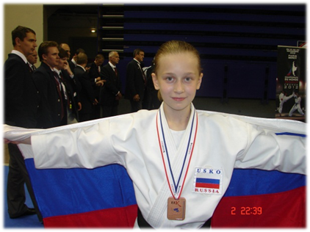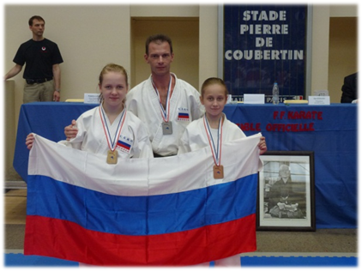

After sport competitions we walked and saw a lot of sights in Paris. The Eiffel Tower is the centre of the city. The Eiffel Tower is an iron tower built on the Field of Mars beside the river Seine. It is the tallest structure in Paris. We lifted on the third floor. There we saw wonderful and beautiful sights of Paris.

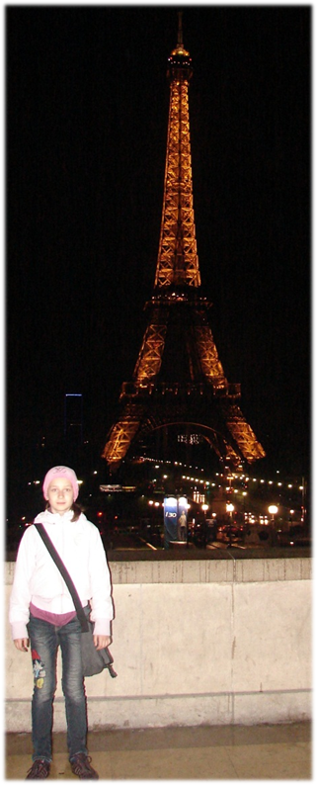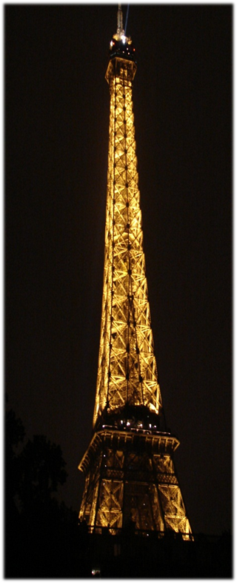

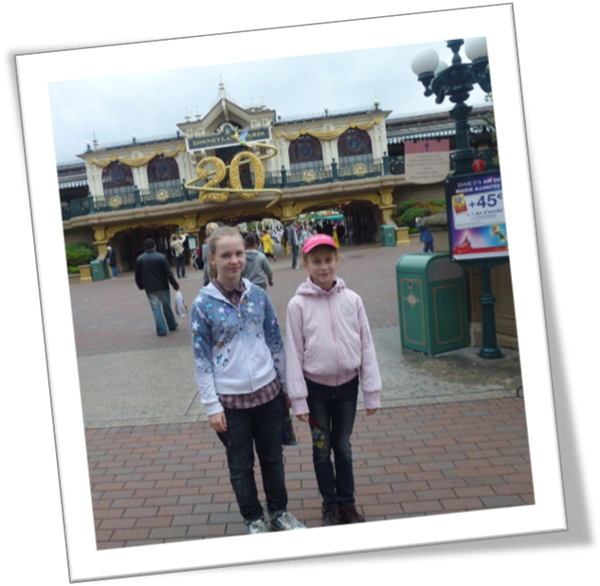
The Disneyland is one of the most popular sights of Paris and France. There we saw all the famous characters of Disney cartoons: Snow White and seven dwarfs, Cinderella, Peter Pen and Pinocchio. Most of all I liked one of the main attractions Pirates of the Caribbean. On Main Street of Disneyland there was a grand parade of characters of our favourite fairy tales and cartoons: Aladdin, The Little Mermaid and others. I had many impressions. I was very happy. My dream to visit Disneyland came true.

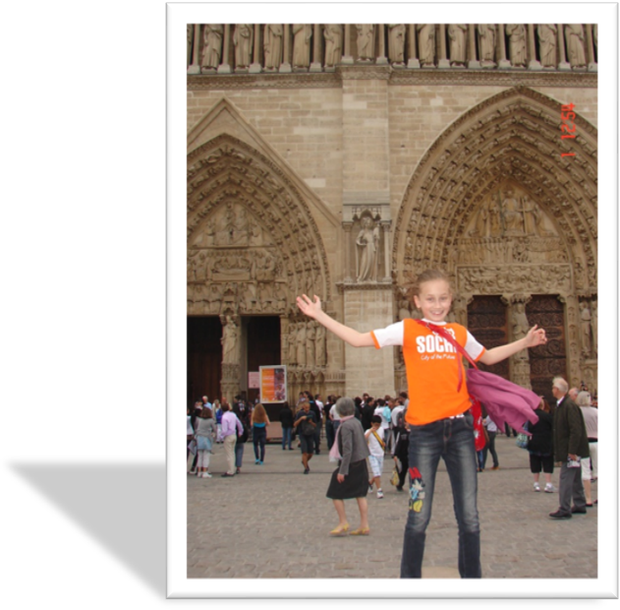

The other interesting places which we visited were Notre Dame Cathedral and Triumphal Arch. Notre Dame Cathedral is the oldest church of the city. We climbed the tower to watch the gargoyles. They are really awful!

Triumphal Arch is a great monument. It honours people who fought and died for France in the Napoleonic Wars. It is the largest triumphal arch in the world.

I enjoyed our travel to Paris very much! This trip made a deep impression on me.
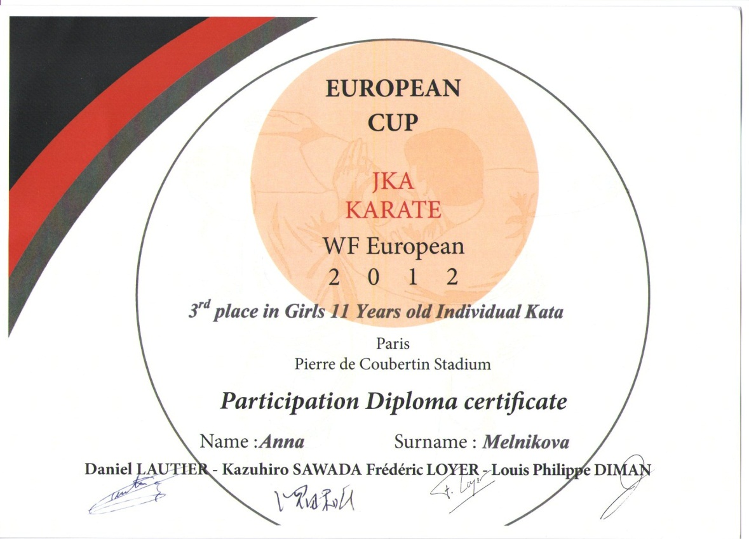
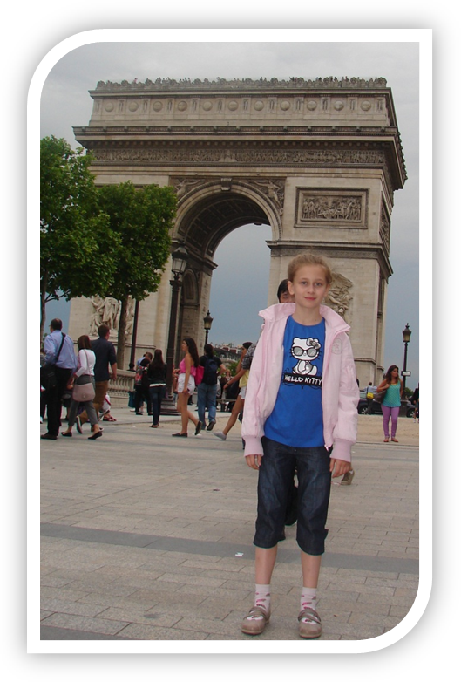

Ссылка на фото для подложки:
http://kk.wikipedia.org/wiki/Сурет:Paris_06_Eiffelturm_4828.jpg
Фотографии из личного альбома семьи Мельниковых, фотографии несовершеннолетних размещены с разрешения родителей.

